EXPERIMENT 6: HIERARCHICAL CLUSTERING
AIM:
To implement Hierarchical Clustering to group students based on study hours and marks and visualize the clustering structure using a dendrogram.
ALGORITHM:
- Import Pandas, Matplotlib, and the required clustering modules.
- Load the dataset from data.csv.
- Select Hours_Studied and Marks as features.
- Calculate the linkage matrix using the Ward linkage method.
- Plot the dendrogram to visualize the hierarchical relationships between data points.
- Create an Agglomerative Clustering model with three clusters.
- Fit the model and predict the cluster labels.
- Add the cluster labels to the dataset.
- Display the clustered dataset.
- Plot the data points using their assigned cluster labels.

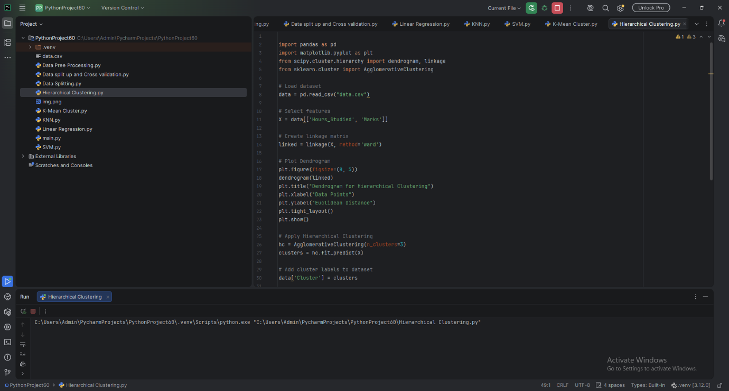

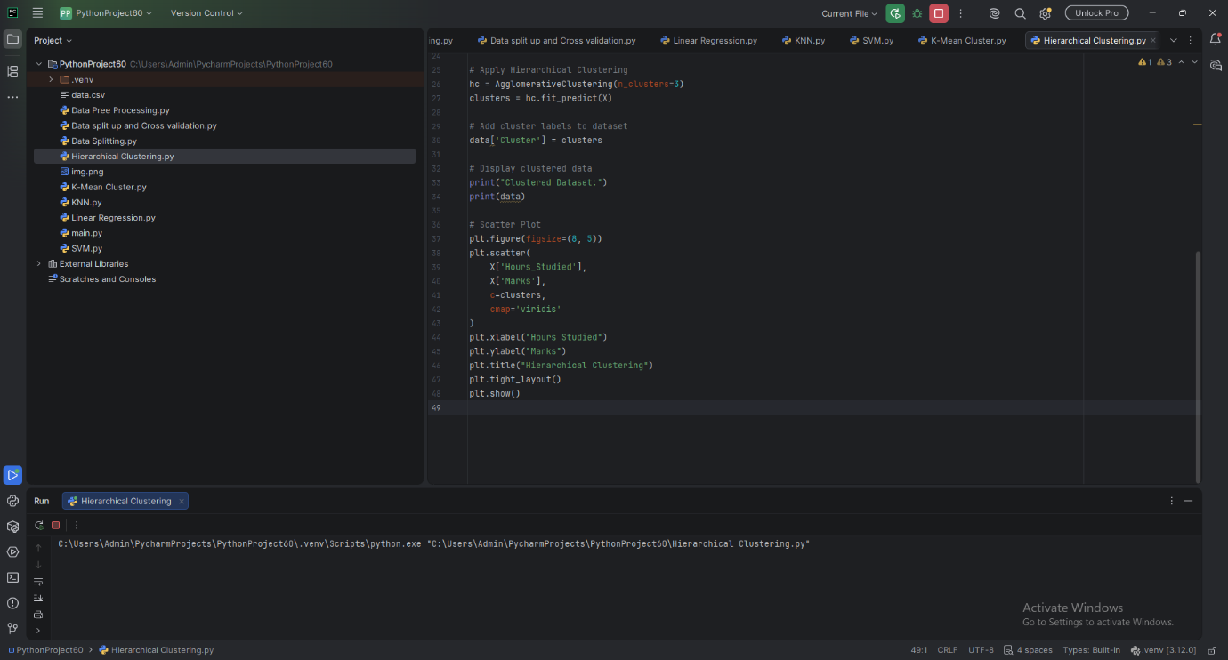

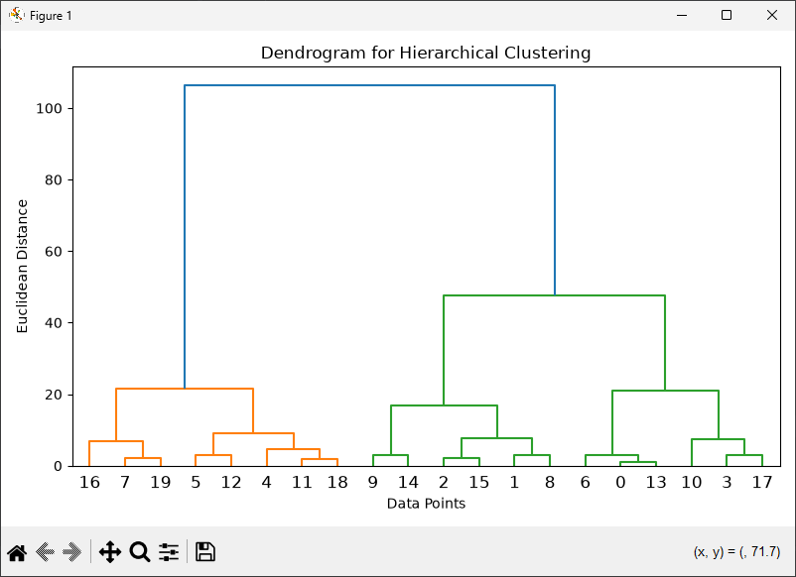
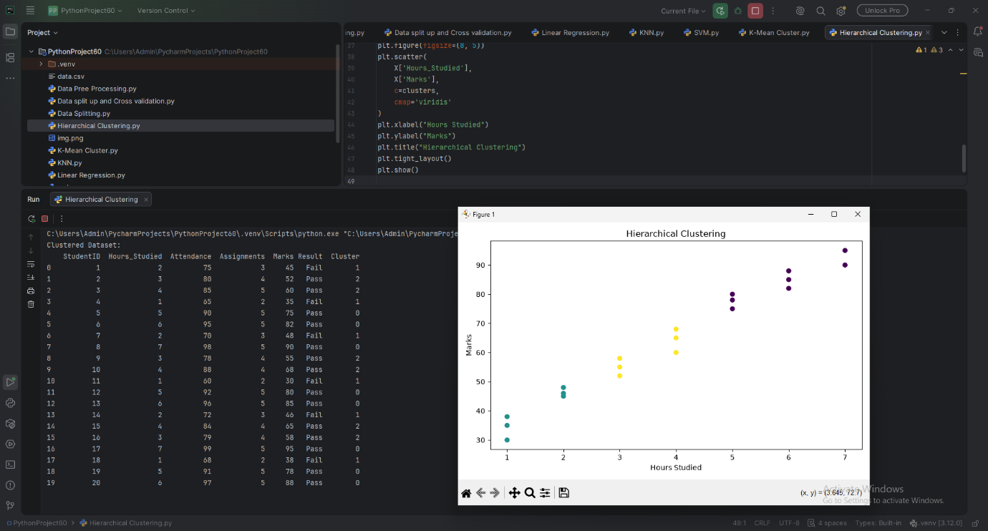

RESULT:
Hierarchical Clustering was successfully performed using the Ward linkage method. The dendrogram and scatter plot were generated to visualize the hierarchical structure and the three resulting clusters.

